Find and locate
The 'find' command in Linux is used to search for files and directories based on various criteria such as name, type, permissions, size, owner, and timestamps. Below is a comprehensive list of commonly used 'find' command examples and options.

Locate Command
locate <dir name>
locate <file name>
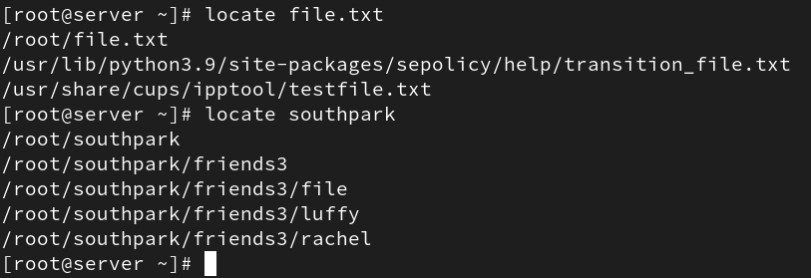
The 'locate' command is used to find files and directories quickly using a pre-built database. It is much faster than 'find' but may not show very recent changes unless the database is updated using 'updatedb'.

Common 'find' Command Examples
- Find Files Using Name in Current Directory:
find . -name data.txt

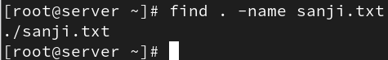
- Find Files Under Home Directory:
find /home -name test.txt
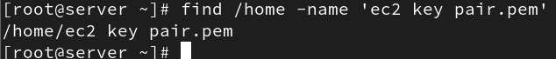

- Find Files Using Name and Ignoring Case:
find /home -iname data.txt
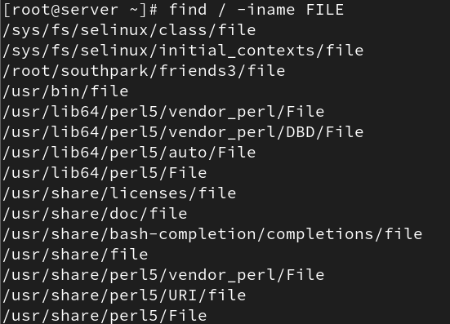

- Find Directories Using Name:
find / -type d -name Data
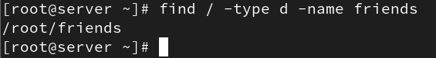

- Find PHP Files Using Name:
find . -type f -name index.php

- Find all PHP Files in the Directory:
find . -type f -name "*.php"
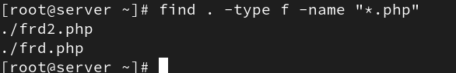

- Find Files With 777 Permissions:
find . -type f -perm 0777 -print
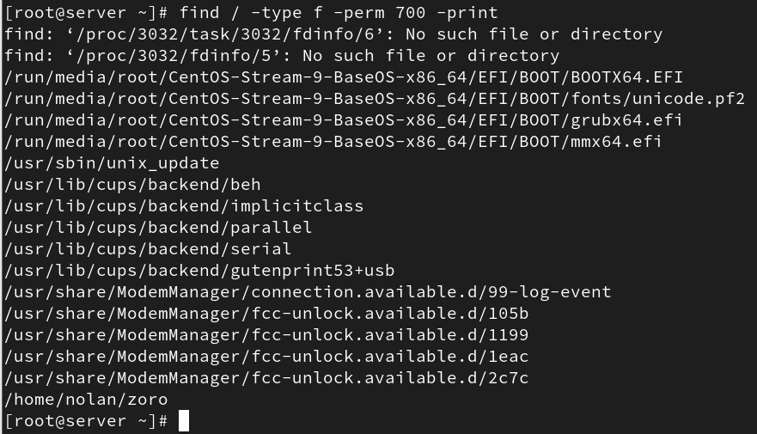

- Find Files Without 777 Permissions:
find / -type f ! -perm 777

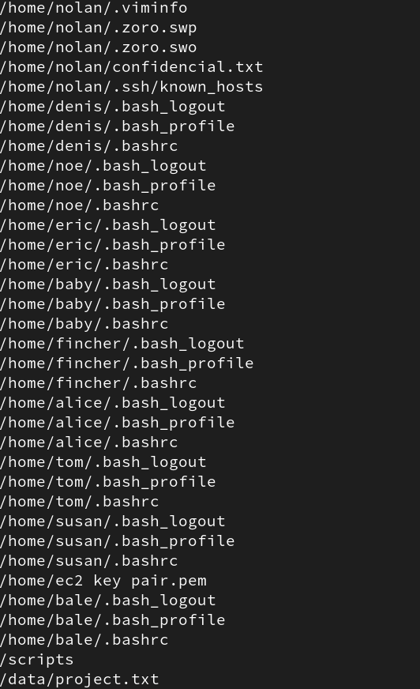

- Find SGID Files with 644 Permissions:
find / -perm 2644
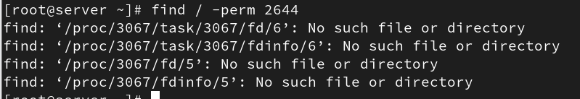

- Find Sticky Bit Files with 551 Permissions:
find / -perm 1551
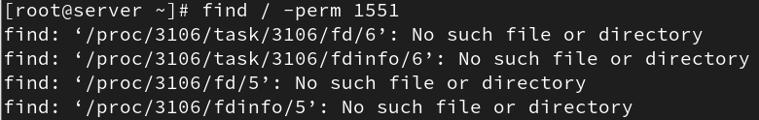

- Find SUID Files:
find / -perm /u=s
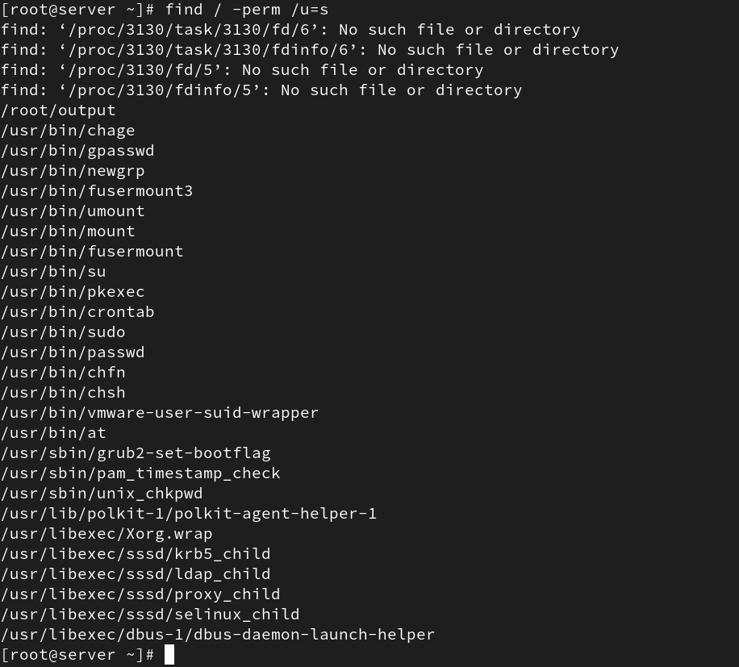

- Find SGID Files:
find / -perm /g=s
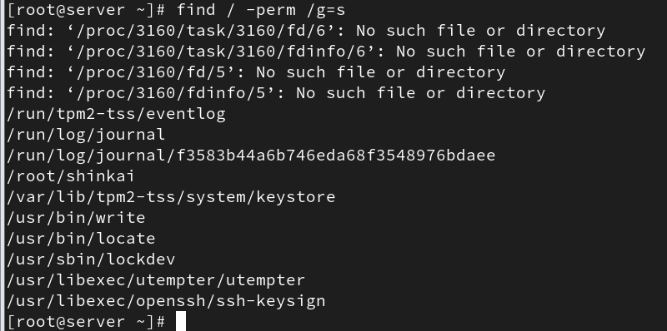

- Find Read-Only Files:
find / -perm /u=r
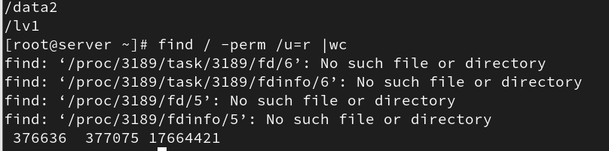

- Find Executable Files:
find / -perm /a=x
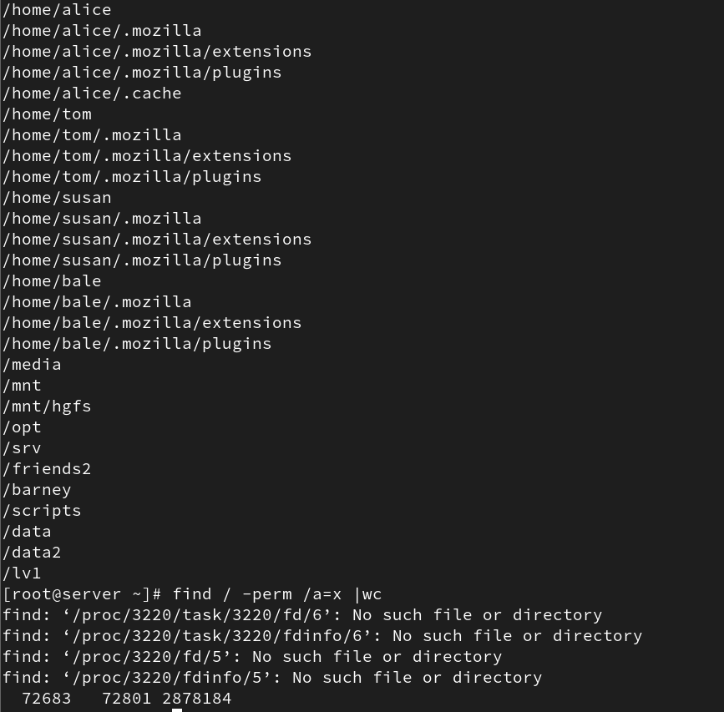

- Find Files with 777 Permissions and Chmod to 644:
find / -type f -perm 0777 -print -exec chmod 644 {} \;
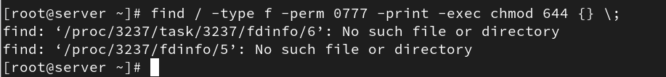

- Find Directories with 777 Permissions and Chmod to 755:
find / -type d -perm 777 -print -exec chmod 755 {} \;

- Find and remove single File:
find . -type f -name "tecmint.txt" -exec rm -f {} \;

- Find and remove Multiple Files:
find . -type f -name "*.txt" -exec rm -f {} \;
- Find all Empty Files:
find / -type f -empty
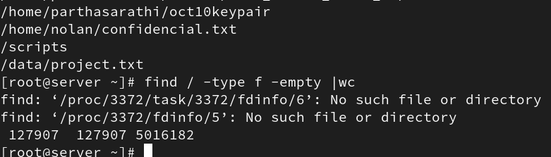

- Find all Empty Directories:
find /tmp -type d -empty
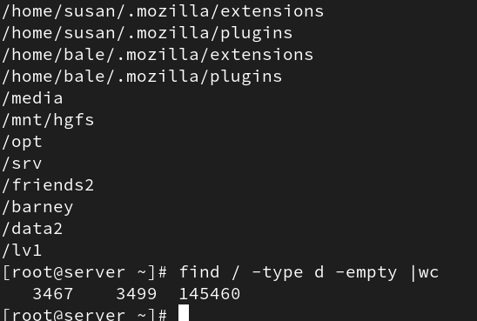

- Find all Hidden Files:
find /tmp -type f -name ".*"
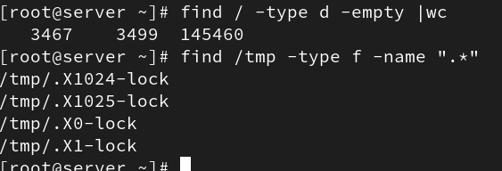

- Find Single File Based on User:
find / -user root -name tecmint.txt
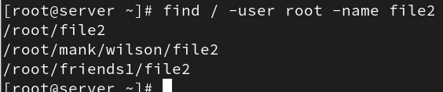

- Find all Files Based on User:
find /home -user tecmint
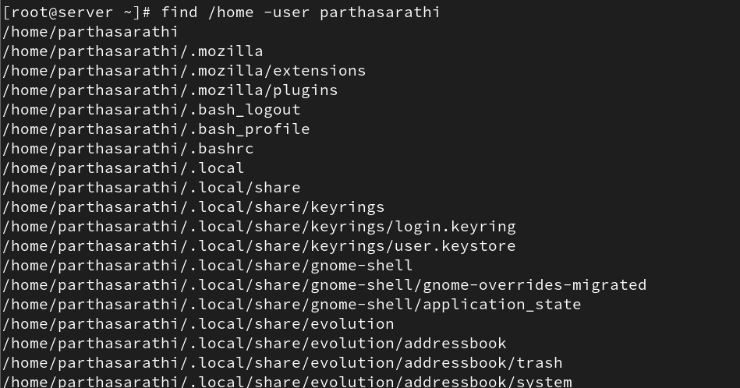

- Find all Files Based on Group:
find /home -group developer
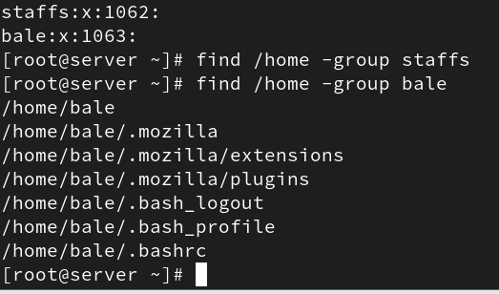

- Find Particular Files of User:
find /home -user tecmint -iname "*.txt"

- Find Last 50 Days Modified Files:
find / -mtime 50
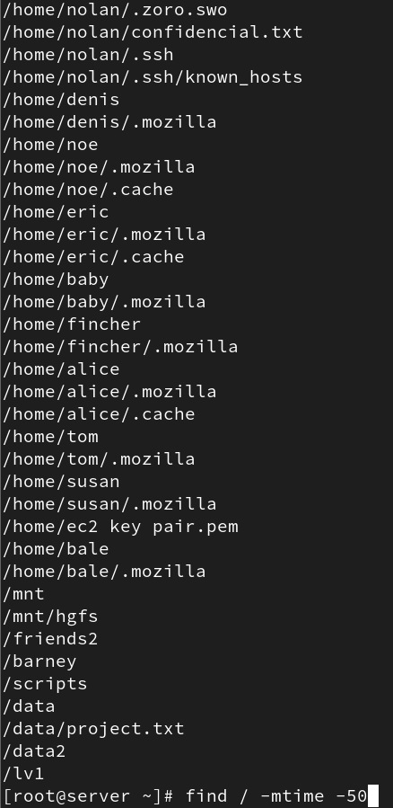

- Find Last 50 Days Accessed Files:
find / -atime 50
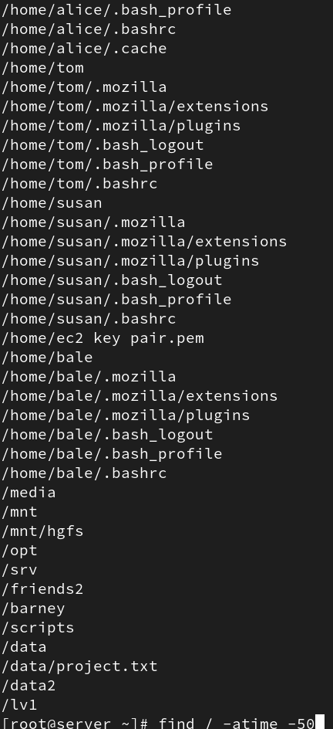

- Find Last 50-100 Days Modified Files:
find / -mtime +50 -mtime -100

- Find Changed Files in Last 1 Hour:
find / -cmin -60
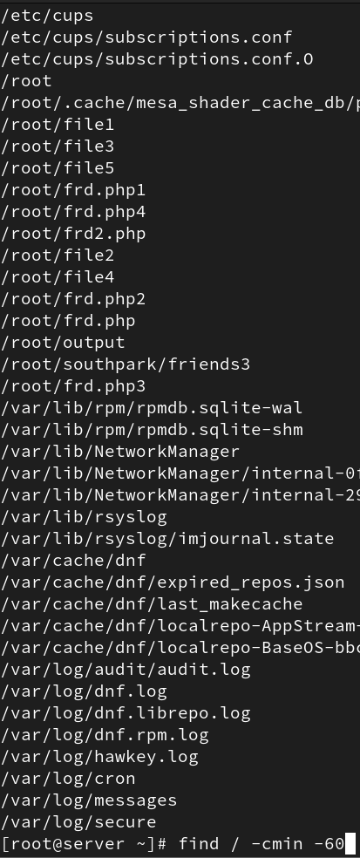

- Find Modified Files in Last 1 Hour:
find / -mmin -60
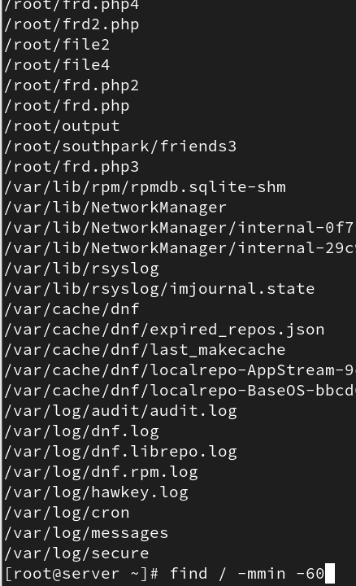

- Find Accessed Files in Last 1 Hour:
find / -amin -60
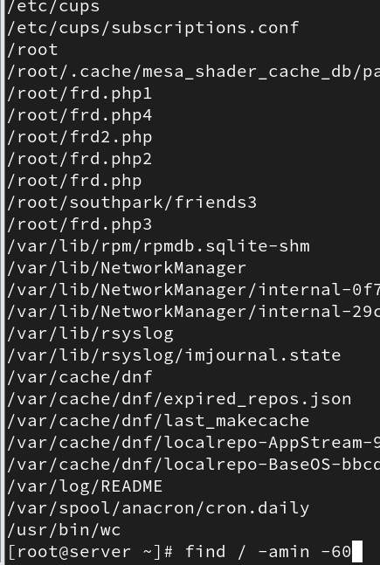

- Find 50MB Files:
find / -size 50M
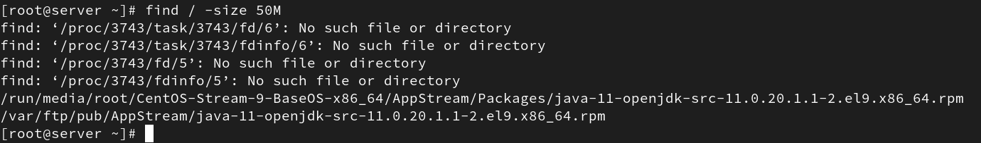

- Find Size between 50MB – 100MB:
find / -size +50M -size -100M

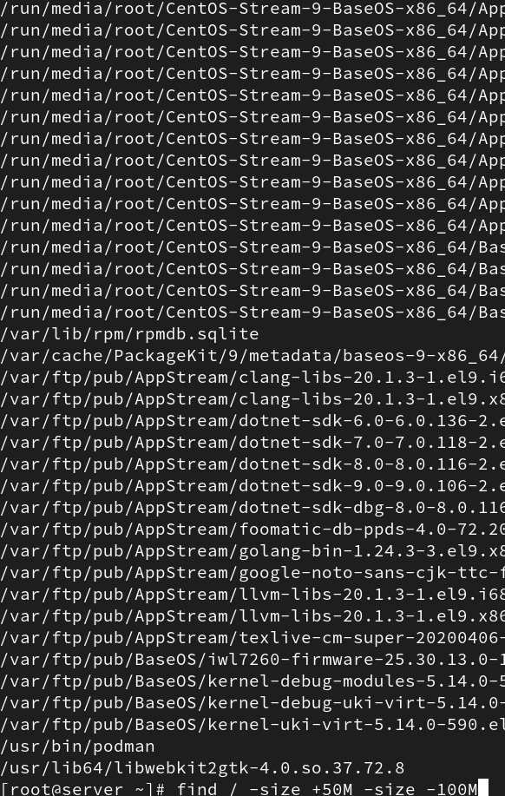
- Find and Delete 100MB Files:
find / -type f -size +100M -exec rm -f {} \;
- Find Specific Files and Delete:
find / -type f -name *.mp3 -size +10M -exec rm {} \;

Explanation of Key Options
- -type: Specifies the type of item to find (f = file, d = directory, l = symlink).
- -size: Searches files based on size (e.g., +100M for greater than 100MB).
- -user: Finds files owned by a specific user.
- -group: Finds files belonging to a specific group.
- -perm: Searches files with specific permission bits (e.g., 777, 644).
- -delete: Deletes matching files or directories (use with caution).
- -exec: Executes a command on each matching file (e.g., rm, chmod, chown).
- -print: Displays the path of each matching file or directory.
- -mtime: Finds files modified N days ago.
- -mmin: Finds files modified N minutes ago.
- -atime: Finds files last accessed N days ago.
- -amin: Finds files last accessed N minutes ago.
- -cmin: Finds files whose status (metadata) changed within N minutes.

